

**Project Report: A Monthly Claim System**

**Project plan**

The Contract Monthly Claims System is a system that aims to streamline the process of submitting and managing claims for lecturers. The main objective of the system is to improve transparency and reliability when handling claims by providing a user-friendly interface and backend management that facilitates efficient interaction between users and administrators.

**Timeline**

The development of this prototype is structured over several phases and deadlines:

1. Project Start: 01 September 2025
2. Week 1-2: Analysis (01 September – 09 September)

* Defining user requirements.
* identifying system functionalities. (01 September – 09 September)

1. Week 3: Design Phase (Due 09 September)

* Create UML Diagrams.
* Develop GUI mockups.
* Gather Feedback from stakeholders on design.

1. Week 4-6: Development Phase (10 September- 24 October)

* Set up WPF (.NET Core) environment.
* Implement login functionality.
* Develop claims status tracking feature.
* Conduct initial testing of developed features.

1. Week 7: Testing Phase (25 October – 01 November)

* Perform unit and integration testing.
* Gather user feedback for improvements.

1. Week 8-9: Refinement Phase (02 November- 15 November)

* Implement changes based on feedback.
* Finalize design and functionality.

1. Week 10: Implementation and Deployment (Due on 21 November)

* Prepare Final Documentation.
* Deploy the application for user access.

**GUI Design:**

The GUI design is centered around user experience, providing intuitive navigation and accessibility. Key screens include:

* Login Screen: Allows users to authenticate into the system.
* Claims Section: Offers options for submitting claims and tracking status.
* Submit Claims Form: Captures necessary data for submitting claims.
* Claim Status Overview: Displays the status of submitted claims.

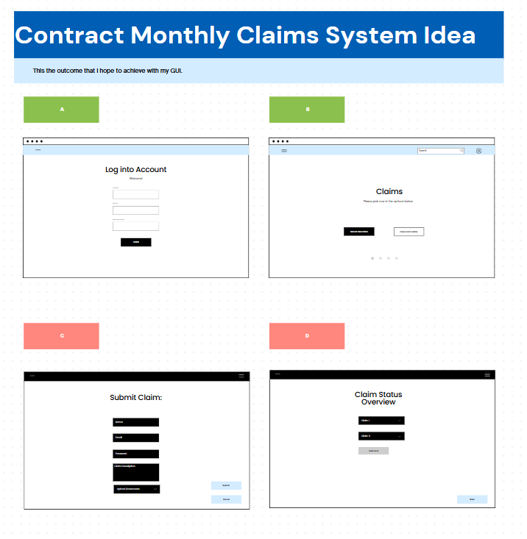

Reference: Design mockups were created using Canva, ensuring a visually appealing and user-friendly interface.

**UML Diagram:**

The UML Diagram represents entities, relationships and keys within the system. This diagram was created using Lucidchart, highlighting the following entities:

* User: The individuals accessing the system.
* Attributes: userID (Primary Key), Email, Password.
* Claim: The claims submitted by users.
* Attributes: claimID (Primary Key), userID (Foreign Key), Description, Status.
* Document: The documents submitted with the claims.
* Attributes: documentID (Primary Key), claimID (Foreign Key), FilePath.

Entity Relationships

* User to claim: one- to-many relationships- a user can submit multiple claims.
* Claim to document: one-to-many relationships- a claim can have multiple associated claims.

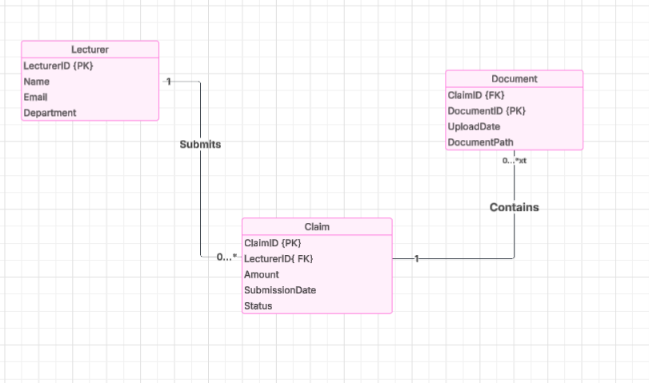

**Task Outline and Dependencies:**

Tasks

* Requirement Analysis: Identify and document user needs.
* Design GUI: Create Mockups and obtain Feedback.
* Develop Features: Implement login, claims submission and status tracking functionalities.
* Testing: Conduct thorough testing across functionalities.
* Documentation: Prepare User manuals and technical documentation.

Dependencies

* Completion of the design phase is dependent on the requirement analysis.
* Development of features will rely on finalized designs.
* Testing can only be performed once features are fully developed.

**Conclusion**

This system aims to be an efficient platform for managing through utilizing tools like WPF (.Net Core), LucidChart and Canva as well as a well- structured development process. This project is positioned for successful implementation.